Project Design Phase
Solution Architecture

Date | 15 February 2025
Team ID | 699d5fb73074df695bbbb046
Project Name | HouseRent Management
Maximum Marks | 4 Marks

Solution Architecture:
Solution architecture is a complex process — with many sub-processes — that bridges the gap between business problems and technology solutions. Its goals are to:
- Find the best tech solution to solve existing business problems.
- Describe the structure, characteristics, behavior, and other aspects of the software to project stakeholders.
- Define features, development phases, and solution requirements.
- Provide specifications according to which the solution is defined, managed, and delivered.
HouseRent Management System Architecture Diagram:

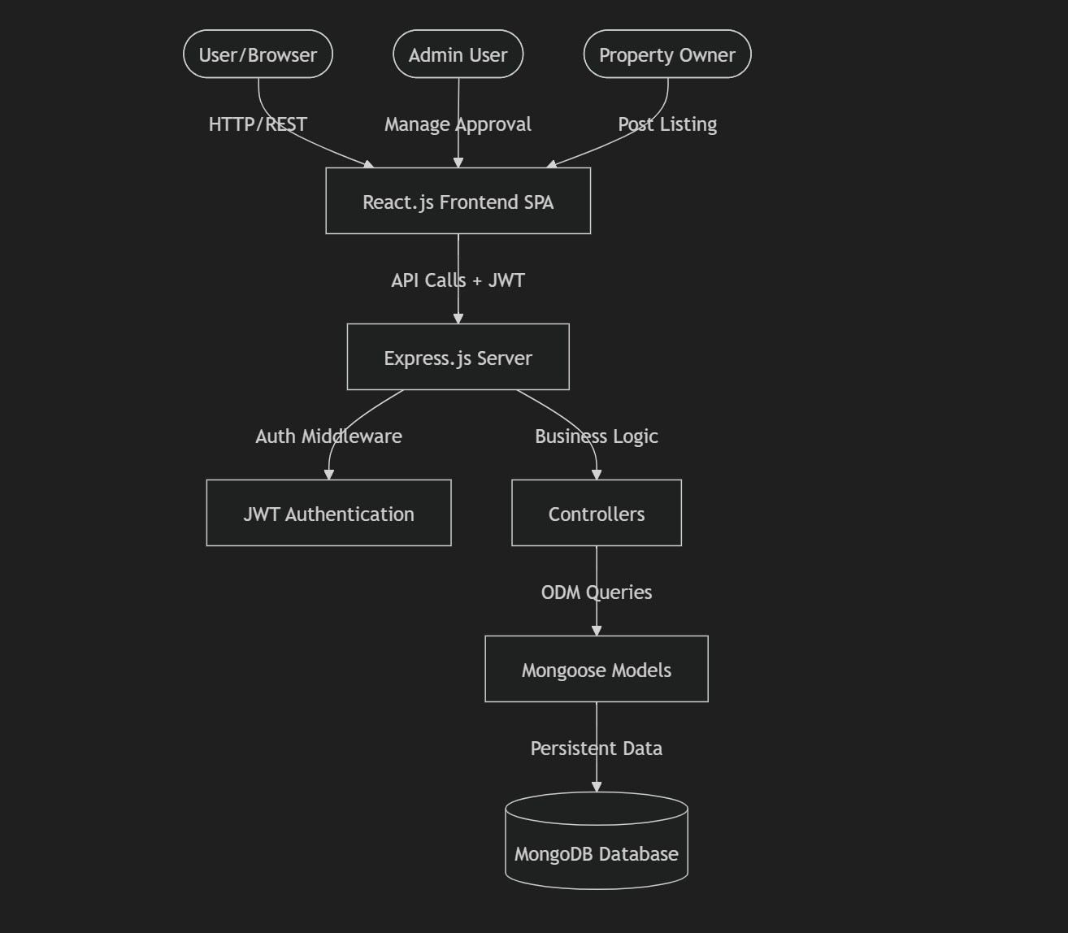
Architecture Overview:
- Frontend: A responsive React single-page application built with modern UI components.
- Backend: An Express.js REST API handling authentication, CRUD operations, and image processing via Multer.
- Database: A flexible NoSQL MongoDB instance optimized for complex property and booking relationships.
- Security: Stateless JWT-based sessions and bcrypt-hashed passwords to protect user identity and data.

